
APPLICATION FORM

1) Name of the Institute / University: _______________________________________________________________________

2) Location (City, State): _______________________________________________________________________

3) Complete Address: _______________________________________________________________________

4) Website: _____________________________________________________________

5) Name of the Principal/Director/Head: _______________________________________________________________________

6) Contact Person Name and Contact details for the event: _______________________________________________________________________

7) E-mail: _______________________________________________________________

8) Telephone & Fax: _______________________________________________________

9) Mobile No.: _____________________________________________________________

10) GST No (If not applicable, please share declaration letter):
_________________________________________________________________________

11) Name of Promoters/Trustees: _________________________________________________________________________

12) Year of Establishment: _________________________________________________________________________

13) Recognition Details: _________________________________________________________________________

14) Award(s) Applied for (Nomination Fee Rs 20,000/- + 18% GST per award entry (Included one delegate):

- A) __________________________________________________________

- B) __________________________________________________________

- C) __________________________________________________________

-D) __________________________________________________________

Award Categories

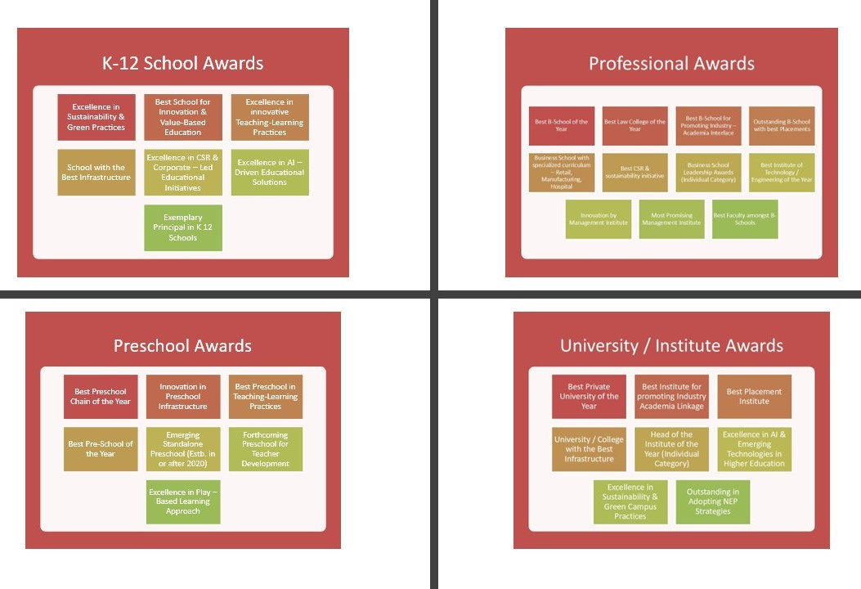

Documents to be enclosed:

- Brief project report of minimum 1000 words outlining the activities undertaken towards contribution to the field of AWARD applied for, and in what ways this contribution holds potential for constructive change and transformation in the field.
- In case you are applying for more than one AWARD please enclose a separate project report and appendix for each category Award.
- The brochure of your Institution.
- Name and contact details of the person who is nominated to attend the summit.
I/ We agree to the following terms and conditions of participation.
- Award Nomination fee per category is Rs. 20,000/- including one delegate participation (plus 18% GST).
- Fee once paid is non-refundable; ASSOCHAM will not be responsible for cancellation or delay of the program for uncontrolled circumstances such as natural calamity etc.
- Nomination form duly filled with the fee shall be considered for short listing process.
- No contact information of short-listing agency or Jury shall be made available and any intervention to award process will lead to cancellation of nomination.
- Institute may opt to apply for multiple awards however the response must be complete in the application for consideration to awards.
- Any misleading information and inaccurate entry found in the form at any point of time will lead to disqualification.
- Jury decision is final and binding on all parties.

All the Cheque/draft should be drawn in favour of “ASSOCHAM Regional Office Kolkata” payable at Kolkata. Bank Transfer Details Account Number 00141110005388 IFSC Code HDFC0000014, Address: HDFC BANK, 2/6 Sarat Bose Road, Central Plaza, Kolkata – 700020.

Payment Details

Cheque No. & Date | Bank Details & Branch Name | Amount ( Rs) | Note if any

Bank Transfer transaction No | Bank Details & Branch Name | Amount ( Rs) | Note if any

For further information please contact:

Mr. Kallol Ghosh || E: kallol.ghosh@assocham.com || M: 7003581862

