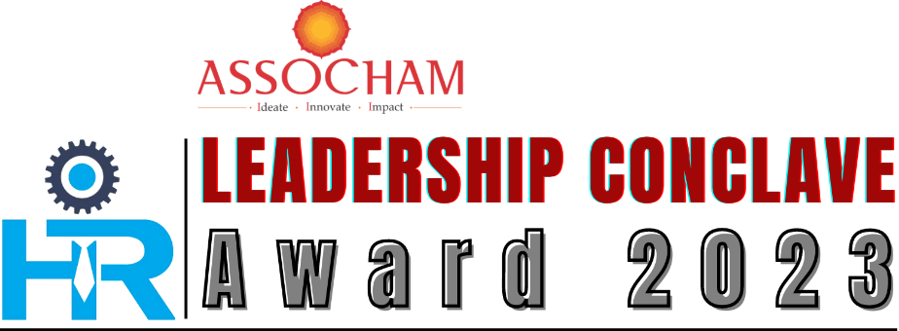

18 January 2023 | 0930Hrs | Hotel New Marrion | Bhubaneswar

Award Nomination Form

Nominee: Organizational Individual (Please indicate the type of participation)

Company/Organization Name:
Participant’s Name:
If nominating more than one person, please provide their Name, Designation & Contact information below

- _____________________________________________

- _____________________________________________

- _____________________________________________

- _____________________________________________

Company Address:
City/State:
Telephone:
Email:
GST No: (If not applicable, please share declaration letter)
Submitted By:
(Name, Designation and contact information) of person submitting the nomination:

Email address of person submitting the nomination
I nominate the above for the following award (*Please only select one category per application.).
Name of Category:
Whether ASSOCHAM Member: YES / NO

Category of HR Awards
Organizational Categories:

Category Name | Criteria | Nomination  Fee
ASSOCHAM |  | Member | Non-Member
Excellence in Business Continuity Planning & Management | To recognize the innovative approach to HR Risk Management practices that assist in business continuity planning, considering challenges related to the evolving compliances and regulations required to maintain a safe and healthy workplace. Entries should be accompanied with evidence of effective investment in technology, systems, procedures, employee safety, etc. to mitigate business reputational risk, as well as effective communication with employees | Rs. 15,000 + GST18% | Rs. 20,000 + GST18%
Excellence in Change Management | To recognize organizations that have adopted corporate policies, structures, systems, and technologies to supervise changes arising out of technology up gradation, reorganization, company policy amendments, crisis mitigation etc. Entries should highlight strategies created or modified that led towards large scale organizational changes to build an agile workforce by focusing on capability building and organizational development, etc. | Rs. 15,000 + GST18% | Rs. 20,000 + GST18%
Excellence in Diversity & Inclusion Practices | To recognize organizations that support diversity and inclusion initiatives at the heart of its business and realize such values through active practices. Entries should demonstrate best practices in diversity and inclusion such as gender equality, a person with a disability, etc. | Rs. 15,000 + GST18% | Rs. 20,000 + GST18%
Excellence in Employee Retention Strategy | To recognize organizations that focus on better employee experience that in turn benefits the organization and shows improved employee efficiency. Entries should focus on the initiatives or strategies laid out for retaining the employees and reducing the attrition rate to as minimum as possible, through parameters such as incentives, values, flexibility, international opportunities, collaborations, etc | Rs. 15,000 + GST18% | Rs. 20,000 + GST18%
Excellence in HR Digital Transformation | To recognize organizations that develop a customized employee experience that meets the needs of the workforce through multiple digital platforms such as data analytics, Artificial Intelligence (AI), Robotic Process Automation (RPA) etc. The focus should be on the right tools to get data and knowledge about your organization and employees which will help your workforce meet their goals | Rs. 15,000 + GST18% | Rs. 20,000 + GST18%

Individual Categories:

HR Leader of the Year | To recognize the CHRO or its equivalent of an organization who has been instrumental in creating a sustainable impact within the organization through exceptional people practices, transforming organizational culture, building and retaining talented workforces, etc. The individual should be a leader in creating a lasting impact made on their organizations and the human resource fraternity. The applicant must have an overall work experience of 10 to 15 years. | Rs. 10,000 + GST 18% | Rs. 12,000 + GST 18%
HR Young Achiever of the Year | This award category recognizes the individuals (HR professionals with less than Ten years' experience) who have made outstanding contributions to their organizations and who exemplify HR’s increasingly strategic role in business today | Rs. 10,000 + GST 18% | Rs. 12,000 + GST 18%
Woman Leader of the Year | This award recognizes the women leader(s) who have excelled in driving sustainable HR contributions to their organization(s) | Rs. 10,000 + GST 18% | Rs. 12,000 + GST 18%

Visit for awards information and criteria. Please email completed form with required documentation by January 10th , 2023, to pradeep.nayak@assocham.com

RESPONSE FORMAT:

Please be as candid as possible and ensure that the required information is shared.
Note: – the information you provide is the only way the judges will have to determine if you will be a finalist.

- Identify and describe the initiatives related to the area of excellence for which you are submitting the nomination. Please highlight in what ways are these innovative or are best practices? (Please describe within 200 words)

- How have the above initiatives benefited your organization, what quantitative and qualitative measures did you use, and what are the results (e.g., impact on business performance, employees' performance, employee engagement, operational efficiency, reduced costs, or mitigation of contained risks, transformation of culture, etc., including trends or comparative benchmarks)? (Please describe within 200 words)

- Please mention the exceptional indicators that make you the deserving winner of the Award in the area of excellence for which you are submitting the nomination.(Please describe within 200 words)

GENERAL GUIDELINES:

Kindly note that companies applying for 3 (three) categories are eligible for a Discount of 10% on the Total application Fee.

NB - All the Cheque/draft should be drawn in favor of “ASSOCHAM Regional Office Kolkata” payable at Kolkata or Bank Transfer to Account Number 00141110005388 IFSC Code HDFC0000014.

Payment Details

Cheque No. & Date | Bank Details & Branch Name | Amount (Rs) | Note if any

Bank Transfer transaction No | Bank Details & Branch Name | Amount ( Rs) | Note if any

For more details you may please contact Undersigned:

Mr Pradeep Kumar Nayak
Asst. Director & Nodal Officer
THE ASSOCIATED CHAMBER OF COMMERCE & INDUSTRY OF INDIA (ASSOCHAM)
Odisha Office: Visa House, 11, Ekamra Kanan, Nayapalli, Bhubaneswar, Odisha – 751015
Mob- +91 9937682012 | Email – pradeep.nayak@assocham.com

